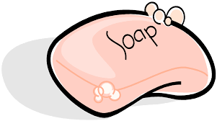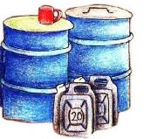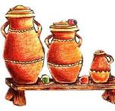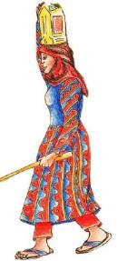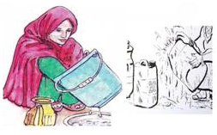

**Mataki na 3** A ajiye ruwa a rufaffen mazubi mai tsafta domin kare shi daga gurbatawar kudaje da kura

**Mataki na 2** Ayi amfani da mazubai masu marfi wajen debo ruwa

**Mataki na 1** A wanke mazubi kafin a debo ruwa. Mazuban ruwa masu datti zasu gurbata muku ruwan shanku

**Matakan ajiye ruwa cikin tsafta**

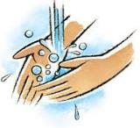

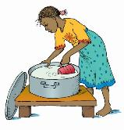

**Mataki na 5** : Ka wanke hannuwanka da ruwa da sabulu domin kare kwayoyin cutar da zasu saka ciwo

**Mataki na 4** :A guji tsoma hannu a cikin ruwa ayi amfani da abin debo ruwa mai tsafta

